**Project Requirements for Big Brother Surveillance System (BBSS)**

1. **Entity-Relationship (ER) Model:**
   * Show entities, relationships between/among entities, and attributes of the entities which can support all the key features specified in the project document
   * Model must be complete and accurately represent the data requirements of the end users.
   * Simple enough for end users to understand, detailed enough for database designers to use.
   * Must follow the Hoffer-Ramesh-Topi Notation.
   * Include all derived attributes in its notation and explain how they are derived.
   * Include any assumed business rules, ensuring they do not contradict the project features.
2. **SQL QUERIES**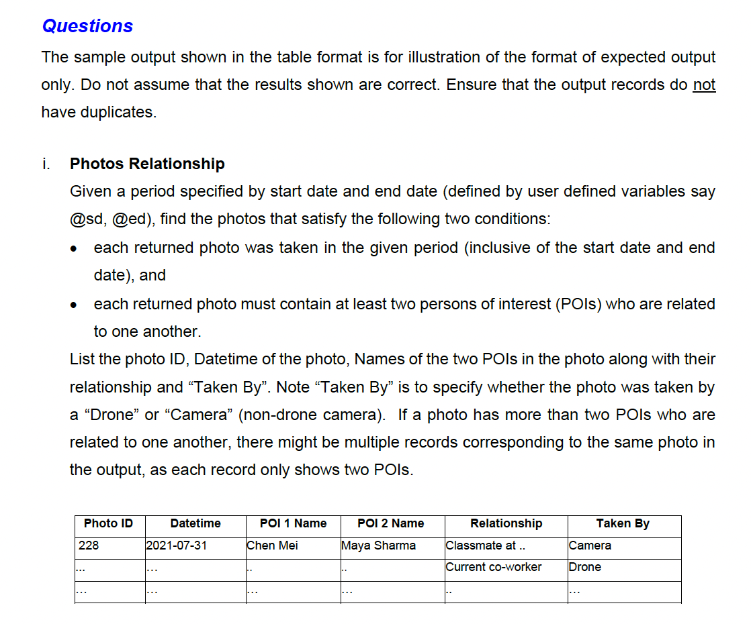A close-up of a document

   Description automatically generatedA screenshot of a document

   Description automatically generated

.

* + A diagram of a company

    Description automatically generated

### Project Logical Design Overview

Here is the detailed logical design for the Big Brother Surveillance System (BBSS). This design includes the entities, attributes, and relationships necessary to support the key features specified in the project document.

#### Entities and Their Attributes:

1. **MISSION**

- ID (int)

- StartDateTime (DateTime)

- EndDateTime (DateTime)

- Description (varchar(100))

2. **AGENT**

- EID (int)

- SecurityClearance (int)

- IsPilot (boolean)

- IsOperator (boolean)

3. **PILOT**

- EID (int)

- PilotLicense (char(8))

- ExpiryDate (Date)

4. **OPERATOR**

- EID (int)

- OpLicense (char(8))

- ExpiryDate (Date)

- OpCertificationID (char(8))

5. **DRONEGROUP**

- ID (int)

- OperatorEID (int)

- PilotEID (int)

6. **GRPDRONES**

- ID (int)

- OperatorEID (int)

- PilotEID (int)

- DroneID (int)

7. **DRONE**

- ID (int)

- DroneModel (varchar(50))

8. **RECORD**

- TrackID (int)

- DateTime (DateTime)

- Latitude (double)

- Longitude (double)

- Altitude (double)

9. **DRONECAMERA**

- ID (int)

- Number (int)

- CameraModel (varchar(50))

10. **TRACKER**

- ID (int)

- DisposeDate (Date)

- AssignDate (Date)

- DroneID (int)

- CameraSN (int)

11. **NEARBY**

- ID (int)

- DateTime (DateTime)

12. **PHOTO**

- ID (int)

- DateTime (DateTime)

- DroneID (int)

- DroneCamNum (int)

- CameraSN (int)

13. **CAMERA**

- SerialNo (int)

- Model (varchar(15))

- Status (varchar(15))

- IsIP68 (boolean)

14. **POI**

- ID (int)

- Name (varchar(100))

15. **PHOTOPOI**

- PhotoID (int)

- POIID (int)

- Confidence (double)

16. **POIRELATION**

- POI1 (int)

- POI2 (int)

- Description (varchar(100))

Relationships:

- Each **MISSION** can have multiple associated **DRONEGROUP**.

- Each **DRONEGROUP** has one **OperatorEID** and one **PilotEID**, which are foreign keys referencing the **AGENT** table.

- Each **GRPDRONES** entry links a **DRONEGROUP** to individual **DRONES**.

- **DRONES** are associated with **TRACKER** and **DRONECAMERA** through their IDs.

- **PHOTOS** are taken by **DRONES** or **CAMERAS** and are associated with **PHOTOPOI** entries.

- **PHOTOPOI** entries link **PHOTOS** to **POIs** (Persons of Interest) with a confidence score.

- **POIRELATION** describes the relationship between different **POIs**.

This design aims to comprehensively capture the requirements and functionalities of the BBSS, ensuring that all entities and their relationships are clearly defined and interconnected.